**Tableau instructions**

Tableau is very like a Pivot table

It is based around measures and dimensions.

Measures are in green = values

Dimensions are in blue = dimensions

Can aggregate the data in different ways just like in Pivot (Sum, average, etc)

1. Drag the different fields into rows and colums. The Cards on the left are also a bit like a third element in this.
2. Marks Cards

They are like a third element in the chart.

1. Maps

Only works withi geo data (see world symbol)

Always drag the geo information into the middle first.

1. Making view where percentage of total category like this:

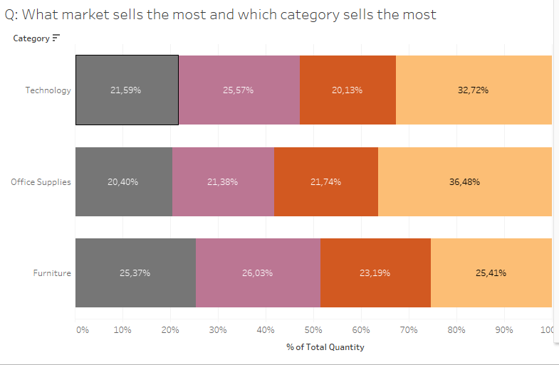

Can only run this on the measures ( in green)

Go to your measure in the table, left click and choose ‘Quick table calculation’ -> ‘Percentage of Total’

Then left click again and choose ‘Compute Using’ -> ‘Table Across’

1. Saving in Tableau

Need to extract file here:

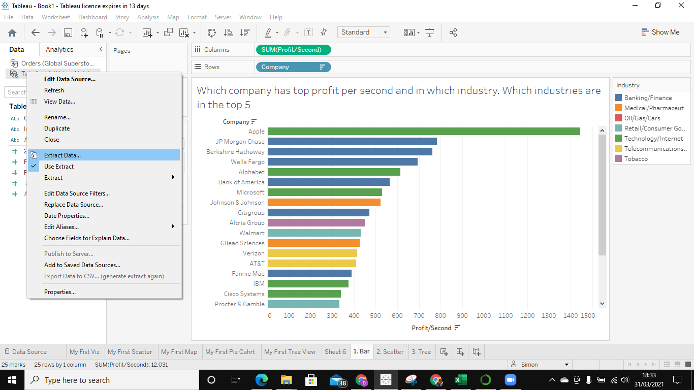

Then save to tableau public here:

